**Digital Nurture 4.0 Java FSE**

**Week 6 ReactJS - HOL**

**Mandatory Exercise (HandsOn 4)**

**Exercise 04:** Create a new react application using *create-react-app* tool with the name as “blogapp”

**Answer:**

**Post.js:**

class Post {

constructor(id, title, body) {

this.id = id;

this.title = title;

this.body = body;

}

}

export default Post;

**Posts.js:**

import React from 'react';

import Post from './Post';

class Posts extends React.Component {

constructor(props) {

super(props);

this.state = {

posts: [],

error: null

};

}

loadPosts = () => {

fetch('https://jsonplaceholder.typicode.com/posts')

.then(res => res.json())

.then(data => {

const postsList = data.map(post => new Post(post.id, post.title, post.body));

this.setState({ posts: postsList });

})

.catch(error => {

this.setState({ error });

alert('Failed to load posts: ' + error.message);

});

};

componentDidMount() {

this.loadPosts();

}

componentDidCatch(error, info) {

alert("Oops! Caught an error: " + error.message);

}

render() {

return (

<div style={{ padding: "20px" }}>

<h1 style={{ color: "#1a73e8" }}>📝 Blog Posts</h1>

{this.state.posts.map(post => (

<div key={post.id} style={{ marginBottom: "20px", borderBottom: "1px solid #ccc", paddingBottom: "10px" }}>

<h2>{post.title}</h2>

<p>{post.body}</p>

</div>

))}

</div>

);

}

}

export default Posts;

**App.js:**

import React from 'react';

import Posts from './Posts';

function App() {

return (

<div className="App">

<Posts />

</div>

);

}

export default App;

**Output:**

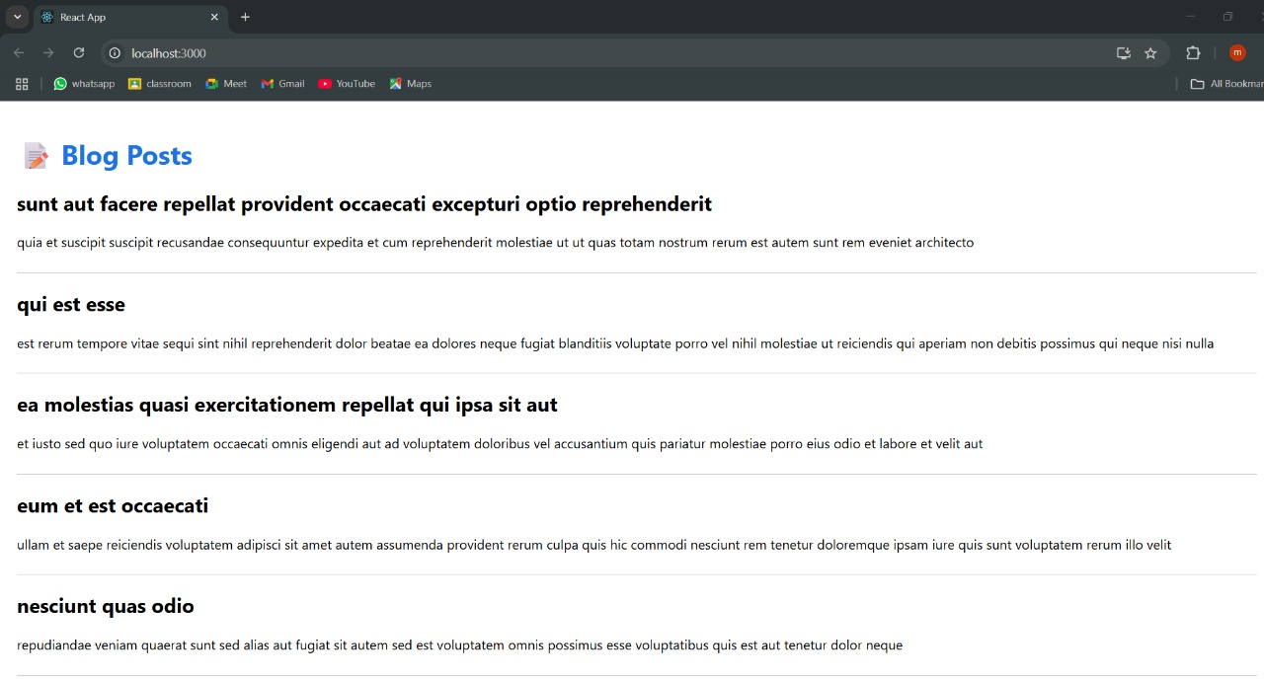**Output is obtained by using json place holder for the blogapp**

